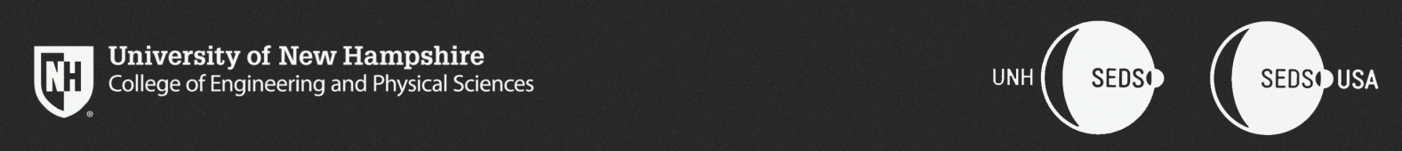  
  
CEPS Student Organization Budget Request  
**UNH Students for the Exploration and Development of Space**

To the CEPS Office of the Dean,

This year marks UNH SEDS’ 4th year being an student organization on campus and within CEPS. We have fostered a community of space-loving students within our home of Kingsbury S172 as well as within our community in CEPS, UNH and the surrounding community. We have hosted 29 senior projects within EE, CE, and ME in just four years. We have successfully designed, manufactured and tested a hybrid rocket engine in preparation for the Spaceport America Cup Competition taking place annually in June, and will continue to optimize the engine into a safe, flight tested design. Lastly, and most importantly, we have created a community that is not reset year-to-year based on senior projects, but is run by all majors and years to create a growing community within the CEPS college. UNH SEDS has a goal of promoting the Aerospace Industry within the CEPS, and the local community surrounding UNH. We feel this industry is truly underrepresented here at UNH and in the northeast in general. The commercial space industry has exploded with size and innovation over the course of less than a decade, and now is the time promote this industry as a potential career path. The future is in space!

There will be 6 seniors working on their senior projects in SEDS this year. More than half the senior members using this organization as their senior project have been in the club since the start. Many of UNH SEDS alumni have graduated and went on to work in the aerospace industry for companies like Space X, Rocket Lab, Department of Defense, Turbocam Int., and Raytheon. SEDS also has built many good relationships with local business that help cut the costs of manufacturing and gain valuable insight from industry experts

Within our budget sheet, we took the liberty to explain each section/sub-section to ensure you understand the ‘why’ of each objective and how the resources listed are critical for its completion. In addition, more than half of the funds we have within our budget contribute to our engineering projects as there will be no travel permitted by the school this year. It is also important to note here that machining expenses are not listed in the budget as we are confident that the relationships we have currently with companies will allow us to utilize the machines and machining time we need for our parts.

For the reason above, we have chosen to ask the CEPS Office of the Dean $**4,489.45** to support the UNH SEDS’ effort to have a launch ready rocket to compete in the Spaceport America Cup in June 2021. Most of these funds will be used to purchase things that only need to be bought once like safety equipment, cameras for data analysis, fire safety equipment, etc. We feel that we can be successful in competition building of the sturdy foundation put in place by the team in the previous year.

UNH SEDS will also be seeking financial assistance from the SAFC for items like apparel and materials needed for outreach within the CEPS college. In addition, SEDS gets help from external sponsors (mostly engineering companies) in the form of cash donations, services, or free components/hardware.

If there are any questions within this packet of information on the story of SEDS and our goals, please do not hesitate to contact the team or myself.

Sincerely,

Alex Chesley